Array

Wiki Help and Tips
This Wiki has a lot of useful information. Here are some tips on finding what you are looking for and ways to relay that to others.

Use the table of contents to navigate.
Located on the upper right side of most pages.

Use the search box to find a word or phrase:
- Search for the words, convention of states, by typing them into the search box.
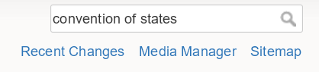
That will find those words in the documents containing them.
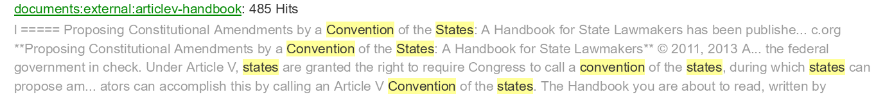
The words found and highlighted may not be adjacent, and each word can be located anywhere in the document.

- You may want instead to search for the exact phrase “convention of states” by using quotes around the text.
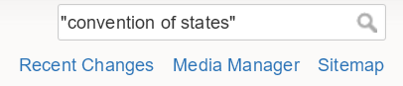
The results from that search are shown here. The result is that the phrases were found, and the words are adjacent.
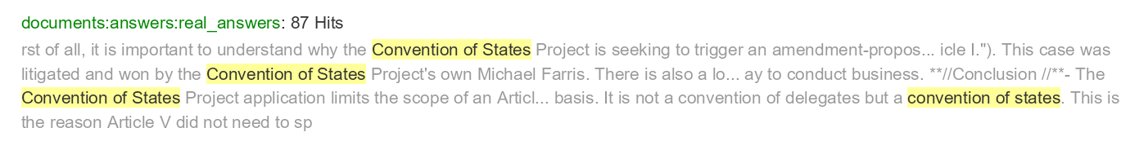
Click on one of the documents found, and it opens. The search phrase is highlighted.
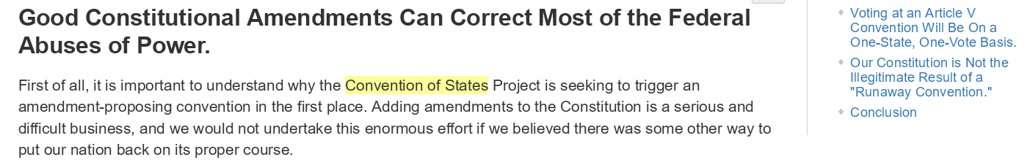
If the document is large it may help to search for the word(s) using the browsers search feature.

TIP Saving a link to the search:
Highlight the text in the URL box, and press CTRL-C or right click, copy. Then go to email, Twitter, Facebook, etc. and paste the link.
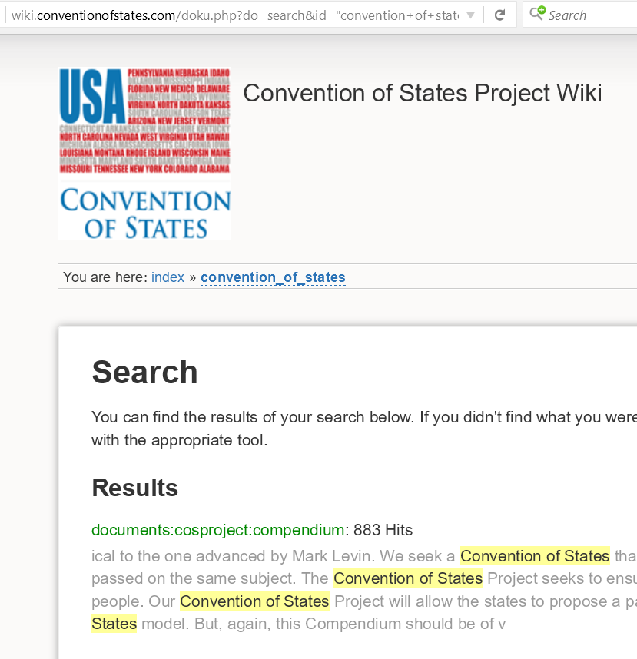

Using tags:
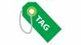 Click on the Tags icon or link on the Wiki main page. Then choose a tag to explore, like nullification.
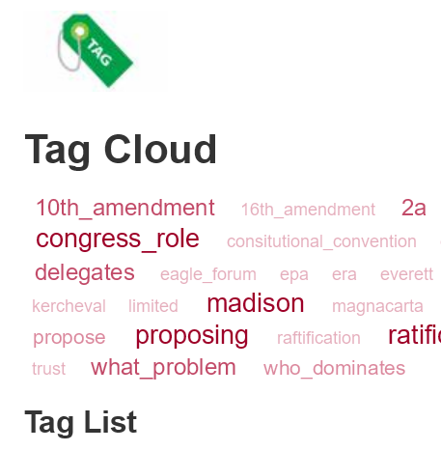
Click on nullification and documents tagged with it are listed.
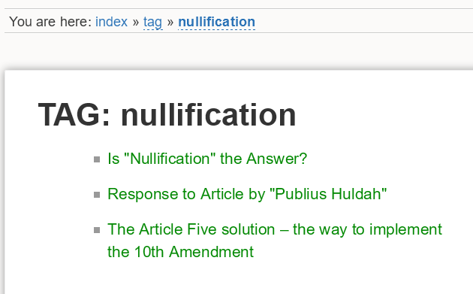
Tip: you can save this tag's search by copying the text in the URL box.
Click on 'nullification-answered' to load that document.
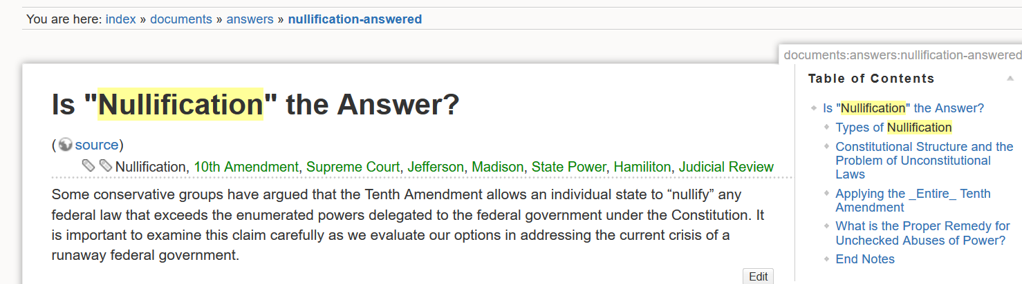
Tip: You can save this document's link by copying the text in the URL box.

Can I point to a part of a document by a link?
Yes, you can point to the beginning of a section, which begins with a table of contents entry.
- For example, in the “Is “Nullification” the Answer?” document, either right click, copy the Table of contents entry What is the Proper Remedy for Unchecked Abuses of Power?
- Or click the Table of Contents entry to go to What is the Proper Remedy for Unchecked Abuses of Power, then copy the text in the URL box. Then go to email, Twitter, Facebook, etc. and paste the link.

Open a tag, search item, or table of contents item in a new tab/window.
Depending on how your browser is configured, this may open either a tab or window. Hold CTRL down (Windows) and left click on the linked item. Or right click on the linked item, Open in new tab or Window.

Sitemap
Use the sitemap to locate a Namespace or document
Links to the sitemap are found on the top right of each page and at the bottom of the main page.

Breadcrumbs
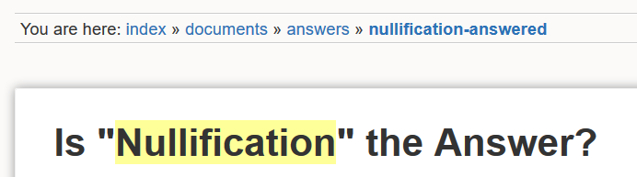
Use the breadcrumb link to navigate back towards the main page.

